**Mountain Pine Beetle**

**Frequently Asked Questions**

What is Mountain Pine Beetle?

The mountain pine beetle (MPB) is a small insect, native to South Dakota that lives most of its life in the inner bark of pine trees.

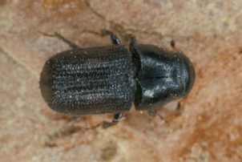

**What does MPB look like?**

The adult beetles are black to rusty brown about ¼ of an inch in length. Their larvae are white and approximately the size of a rice grain.



How do MPB kill the tree?

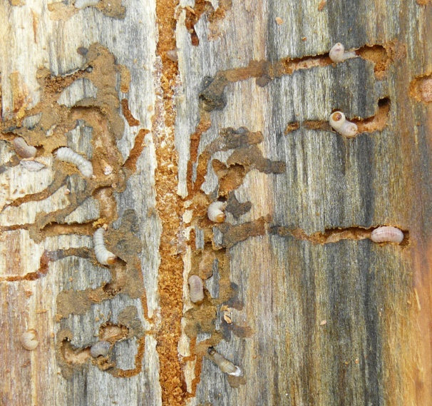The beetles colonize trees in large numbers. The tunneling beneath the bark by the adult beetles and their larvae disrupts the movement of food, produced by the needles, to the roots. The adult beetles also carry a blue stain fungus from tree to tree which disrupts the flow of water through the tree. The combination of these factors results in the tree’s death.

When do MPB fly?

In late June through September, after the larvae have matured into beetles, they will be ready to leave the tree. The beetles usually leave the tree in large numbers at the beginning of August and flights will taper off by September. The peak is usually during Sturgis Rally Week.

How far will MPB fly?

Given that MPB is not a great flyer, they typically will fly less than 300 feet.

Can I spray my trees?

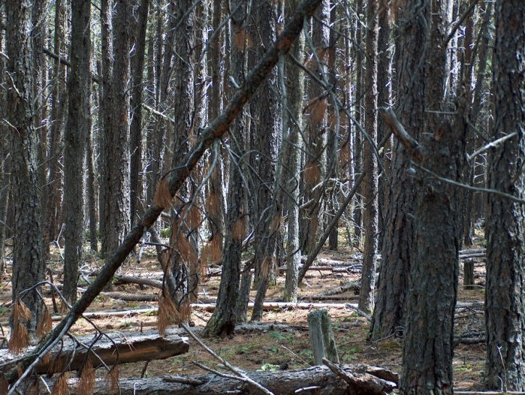The only treatment that can be applied to the tree is preventative. This will protect the tree by killing the beetles before they infest the tree. Treatments using permethrin or carbaryl should be done by early July to protect trees from MPB. The product should be applied from the base of the tree to a height of 35 feet or where the trunk narrows to 5 inches in diameter. Once a tree has been attacked it is too late.

What size of trees do MPB attack?

MPB will usually attack trees greater than ten inches in diameter. They will attack trees down to 4 inches in diameter when the MPB population is high.

How far up the tree do they attack?

MPB usually will attack the main stem of the tree up to the point where it is 4 inches in diameter.

How many MPB does it take to kill the tree?

The exact number is not known. If there are beetles that have entered on all sides of the tree, it may be a small number. But there is no simple answer unless a trained professional can see the tree.

What trees do MPB attack?

Normally trees that are weakened or stressed are susceptible to being attacked. In areas that are heavily infested, all trees are susceptible.

What causes the MPB population to increase?

The exact cause is not known, but the availability of mature dense forest stands is a common factor with most increases.



What is a “pitch tube”?

This is a physiological response from the tree where the MPB has entered or tried to enter the tree. The resin or “pitch” in the tree secretes out around the beetle and forms somewhat of a tube that looks like a piece of gum. The pitch tube is usually red in color due to the boring dust from tunneling into the bark of the tree.

I have five, white-colored, “pitch tubes” on my tree - is it infested?

White pitch tubes indicate that the beetle was not successful in entering the tree at that spot. You will want to look for other signs, such as red colored boring dust at the base of the tree and in the bark crevasses.

There are large red “pitch tubes” at the bottom of my tree, is it MPB?

“Pitch tubes” that start at ground level and are not higher than your waist are caused by red turpentine beetles. This beetle is usually not a tree killer.

Why do I have only one tree infested?

In areas where populations aren’t at a high level, there are usually single trees or small groups of trees infested. If you are in a heavily infested area, your neighbor may have several trees infested and you were fortunate.

What kills MPB?

The adult beetles die after they have laid their eggs. Some of the larvae and beetles are eaten by birds. There are other beetles that feed on them, as well. Some are killed by fungi and disease.

Will MPB get into my dry firewood?

No, they need live material to feed and lay their eggs.

Will MPB get into my green firewood?

No, but a different beetle can. Because of the chance that pine engraver beetles will get into fresh cut pine, you should not stack green firewood near or against other trees.

Are the large grubs I find when splitting firewood MPB?

These are the larvae of wood borers and will only be found in dead or dying trees.

Do I have to worry about the branches?

No. MPB only affects the main stem of the tree.

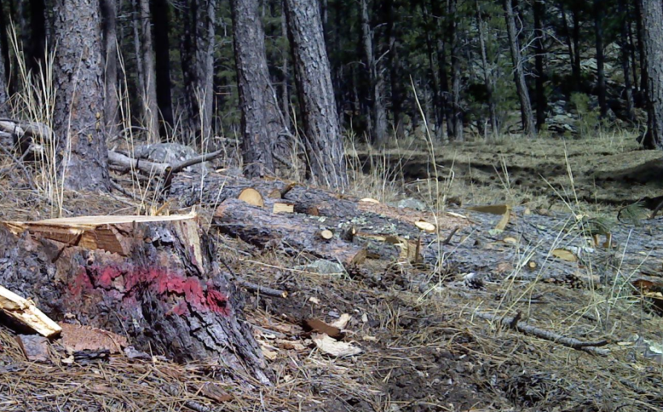

Is it safe to move the green infested wood to another location?

It is never a good idea to move firewood or logs a long distance from where you gather them. MPB larvae can survive and mature in green infested wood that is not properly treated and emerge to infest nearby healthy pine trees.

If I live outside of the Black Hills, do I need to worry?

If you have no pine trees or so long as no infested wood is brought to your residence or your neighbors, you shouldn’t have a problem.

How do I deal with an infested tree?

Trees can be cut and chipped or completely de-barked onsite. Both of these methods will produce near 100% beetle kill, but can be very labor intensive. Probably the most reasonable treatment that leaves the trees on site is cutting the infested tree down and then cutting the log into 2 foot lengths. The cut pieces should not be stacked and should be left exposed to as much sun as possible. This will cause drying of the inner bark tissue and beetle death. The part of the log that is in contact with the ground will remain somewhat protected and will produce some beetles. Generally, the amount surviving on the underneath side is relatively low, 10-20% of the total. If there is concern about killing these beetles the logs can be rotated at least once after cutting to ensure all sides of the log dry. Treatments should be done as early as possible (before March 1) to allow for maximum drying time. Infested trees can be cut and burned; however, infested trees are green and wet and so are difficult to get temperatures hot enough to kill the beetles inside.

